Editing your pictures with local adjustments using Lightroom
The editing process so far
Over the past few episode of this series, we have focused on the photographic workflow in Lightroom. Firstly we looked at importing and key-wording images into the Lightroom catalog, and then looked at selecting and ranking pictures for developing. The last article was about enhancing the picture using the develop module using global adjustments. Global adjustments are great for working on enhancing the whole picture. However, sometimes we need to enhance select parts of the picture.
Local adjustments
Local adjustments are applied to selective parts of an image by using a powerful range of tools and brushes. This tutorial will go through the local adjustment tools and give examples of how they can be used. In the global adjustments article we explained how Lightroom supports a non-destructive approach to picture editing, local adjustments are based on the same method, except it uses a concept of masks and pins to apply the selective adjustments, rather than layers.

The Brushes & Tools
Gradient Filter
In traditional photography the graduated filter is used to balance the exposure in the scene by placing it in front of the camera lens. It is often used in landscape photography, i.e. when the sky is too bright and foreground is too dark, the camera may not able to capture all of the tonal range, and over expose the highlights or underexpose the shadows. This filter will allow you to protect the highlights and shadows balance the exposure.

The graduated filter can be found fourth from the left in the tools and brushes collection underneath the histogram in Lightroom (in the picture below, the gradated filter is selected and is highlighted in white).
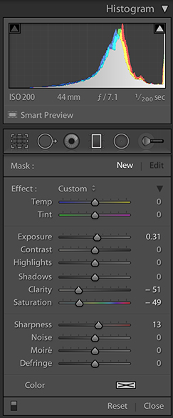
In the picture below the sky is quite bright and I would like to make it darker.
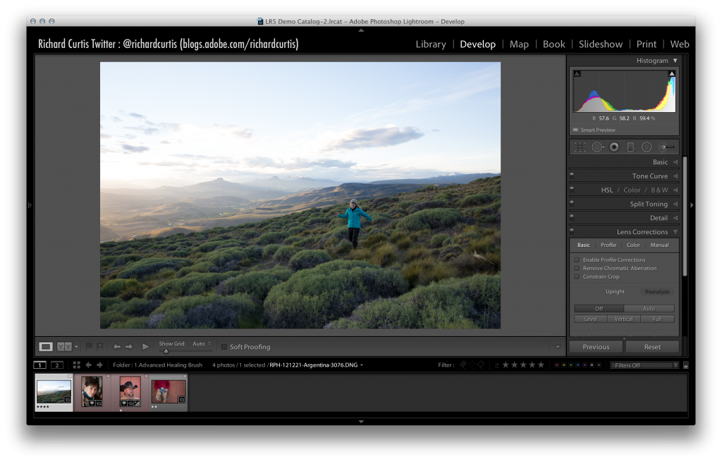
The graduated filter (marked in yellow below), can be used to alter any of the attributes that appear in box below it. In this case the exposure value will be used to darken the sky. Any of the attributes or combination of them can also be changed, i.e. highlights, shadows and clarity, even the colour.
Operating the graduated filter
The graduated filter is placed on the picture by clicking on the image; a placeholder pin is automatically created for you. The graduated filter pin is not fixed; it can be dragged into another position using the mouse or pen. In the following example the mask pin is placed inside the horizon area (marked red below), and the graduated filter (white lines) is placed off center and rotated slightly. The graduated filter is rotated to make sure that the filter is not seen in the final finished picture.
Once the filter is in place, the exposure slider (blue) is moved to the left and darkened. The gradient filter includes a feather so it should be blended into the scene.
The graduated filter can also removed from the picture, by selecting it and pressing the delete key or right click with the mouse on the pin and choose delete.
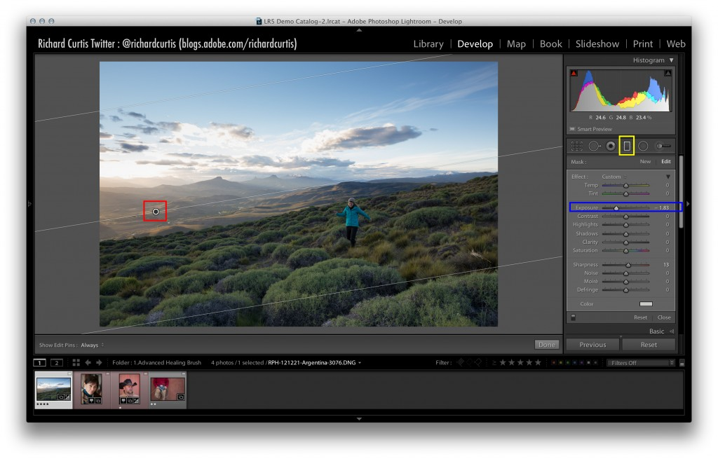

Cloning and Healing
Some times a picture contains issues that you may want to fix. These issues could range from dust spots to a piece of litter and will depend on the style and story that you may want to tell, or it may just have an impact on the picture in general. The clone and heal tool is used to fix parts of the picture by replacing the problem area with another part of the scene.
In the example below there is some bracken within the grassy areas in the bottom right of the scene (marked yellow below), and we will use the clone and heal tool in Lightroom to fix it, or at least reduce the intensity of it and blend it into the scene.
Before the clone or heal operation takes place, it is good practice to work zoomed in, or in a close up view mode. Working at 100% or greater will allow you to see the finest of details, and make sure that the areas that are being cloned/healed are blended into the original scene, then the viewer won’t be aware of the fix.
Lightroom can be put into 1:1 or 100% view by clicking on the 1:1 icon (marked red below). Once you select the clone/heal tool (marked in pink), the tool controls will be displayed (marked blue).
The operational controls for the clone/heal tool are: –
- Size – controls the size of the tool
- Feather – amount of softness on the edge of the tool
- Opacity – How much of the picture under the new clone/heal section will be visible.

The area that needs to be fixed is marked in yellow box below.
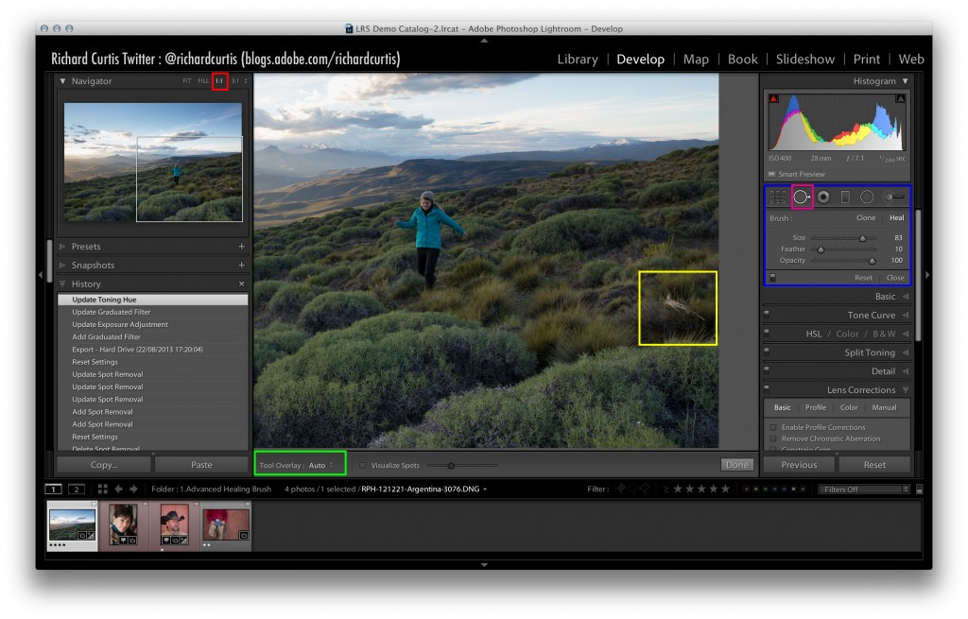
Operating the Clone/Heal tool.
Once the tool is moved over the picture the brush will become visible.
The size and feather of the clone heal tool are controlled using the sliders (marked in the blue box above), or by pressing the ‘[‘ key for decreasing the size, and ‘]’ for increasing the size. Holding the SHIFT key at the same time as the square bracket key can change the feather amount.
To place a new clone/heal brush on the picture, make sure ‘New’ is selected in the tool panel (marked in the blue box above), and click on the picture. Lightroom will automatically try and find a replacement area. If the area that is selected is not suitable, press the ‘/’ key and allow Lightroom to select a different patch source.
You may need to play with the brush size; it’s location, and the other attributes to cover the area that needs to be cloned/healed. Once the tool has been placed on the picture, two rings and an arrow will be shown for each clone/heal. The ring with the arrow pointing away from it is the new source patch, and the other is the destination.
To achieve the best results, you may need to move both rings independently by using the mouse or pen so that you have the right destination and the new source will blend into the picture without it being visible. Also, don’t forget you can change the size; opacity and feather at any point in time to get achieve perfect results.
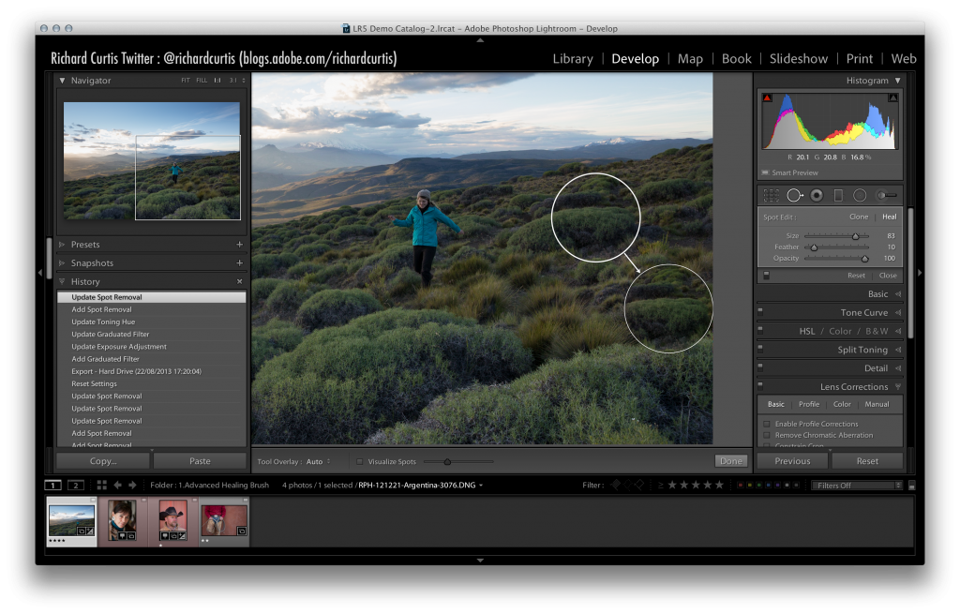

By default the clone/heal tool will create a circle for the path, but sometimes, the round brush is the wrong shape and what’s really needed is a custom shape.
When you click on the picture to place the tool, don’t take you finger of the right click button of the mouse or pen, but instead, drag it, and a white shape will be drawn. Now you can manually draw the patch and create a custom shape for the repair.
When you are altering the attributes of the tool, especially the feather, you many want to see the effect on the picture while it is being changed. This can be difficult to see when the rings are always displayed and can be more challenging when more than one tool has been created in close proximity. To control the visibility of the clone/heal rings when they are not selected, review the “Tool Overlay” option (marked red below) :-
- ‘Always’ will show the clone/heal points at all times,
- ‘Auto’ will make sure the source is hidden and just the destination repair is shown when you hover over the picture. Once you leave the picture area, the tools will be hidden.
‘Auto’ is good start for seeing the adjustments as they are being applied.
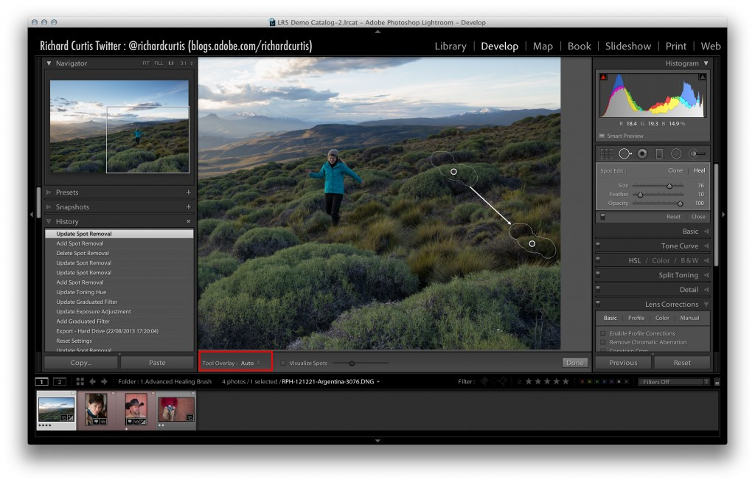

When repairing the picture, there can sometimes be other marks that are not always easy to find, i.e. dust spots, sensor smear, or maybe some items that are just difficult to spot. To resolve this and make this type of repair much easier, you can turn on the visualise spots mode (marked red below), the picture will turn into a black and white mask, showing difficult to find issues. Clone and heal repairs can also be applied in this mode.
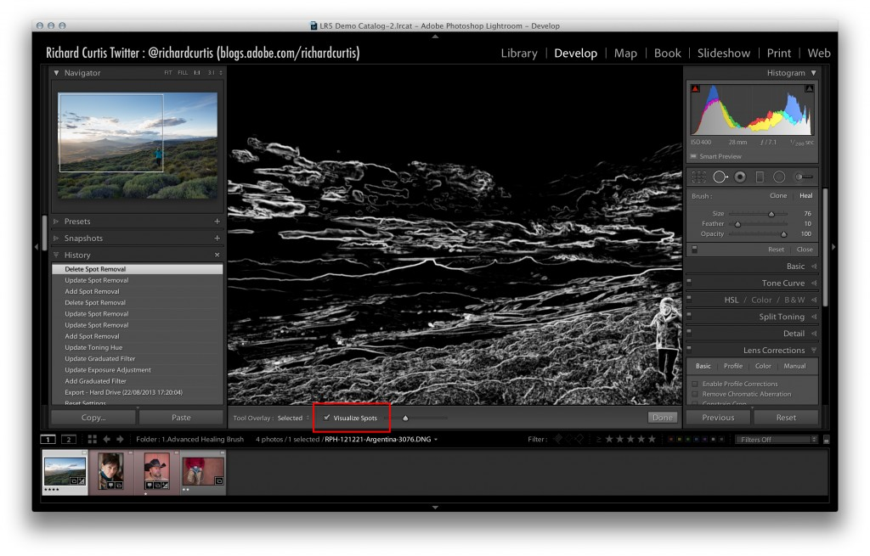
Adjustment Brush
The adjustment brush is invaluable for selectively painting enhancements onto the picture. There are so many uses of this brush, it will be challenging to talk about them all here, and will of course depend on your creative vision. In this tutorial we will focus on three areas that will hopefully give you a good basis of how to use the tools.
- Add some depth into the shadows of the foreground
- Change the colour of the persons jacket
- Change the brightness of the whites of a person’s eye, to add interest.
Scenario 1 – Add some depth into the shadows of the foreground

In this example we will add some depth to the shadows and increase the contrast in these specific areas.
We will use the adjustment brush to paint a mask on the picture, but just in the areas of shadow in the foreground. The mask that we will create will be a percentage of the full strength of what is possible with masks in Lightroom. This approach will enable us to layer up any adjustments that we need to, and enable us to and keep control and work with precision. Once we have placed brush strokes on the image, we will then decrease the exposure in these areas only using the exposure slider.
Operating the Adjustment brush tool.
Select the Adjustment brush (marked red below), and note the show pins (marked dark blue), is positioned to ‘Auto’. When the show pins setting is set to ‘Auto’, Lightroom will make sure that each pin and it’s mask is only visible when it’s selected, and the cursor is hovered within the image area. Once the mouse is moved outside of the image area, all pins will become hidden. When the ‘Show selected mask overlay’ (marked pink below) is set to on, the Red mask will be displayed over any adjustments. This option is good for seeing where the adjustments will be made, as well as the strength of the current mask. The ‘Show selected mask’ can also be turned on/off by pressing the ‘O’ key.
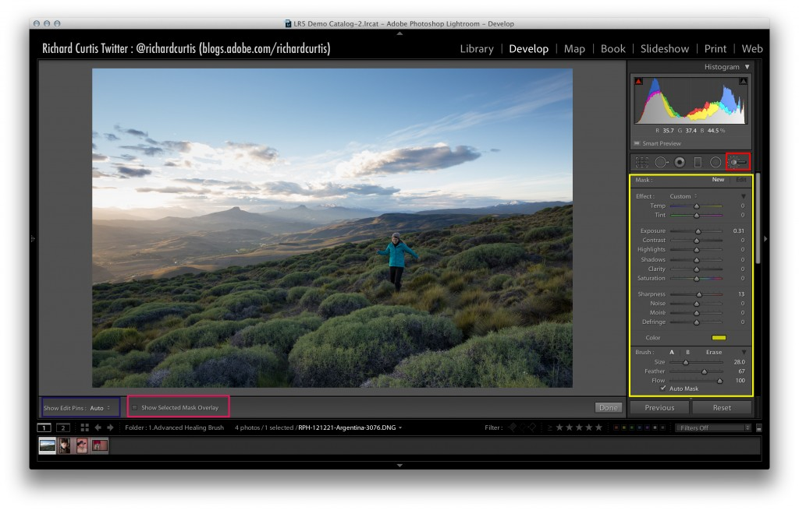
When painting with the adjustment brush, the default setting is adding to the mask (this will be displayed as a + sign in the brush). However, you may also want to remove areas of the mask, this can be achieved by pressing the “ALT” key at the same time as painting (this will be displayed as a – sign in the brush).
Multiple masks can also be created on an image to add different effects in different areas. To create a new mask, make sure that you click on the ‘new’ option on the attributes panel (marked yellow above). To edit an existing mask, you click on its pin. Once you have clicked and selected a pin, a black mark will be displayed, indicating that it has been selected (marked light brown below).
Before you paint for the first time, I would recommend turning on the “Show Selected Mask Overlay” (marked red below) by clicking the check box, or by pressing the ‘O’ key (this toggles the option on and off). This will show the mask as you paint.
Masks that are painting onto the picture do have properties (marked yellow below). The strength of the mask is controlled by the flow attribute, the lower the flow the more control you will have when applying the effect (The idea of a low flow value is to enable a controlled build up of the mask, as well as the effect that is being applied).
To darken the areas that we have created the mask for, the exposure will need to be decreased (moved to the left), this will effectively darken the shadows under the mask.
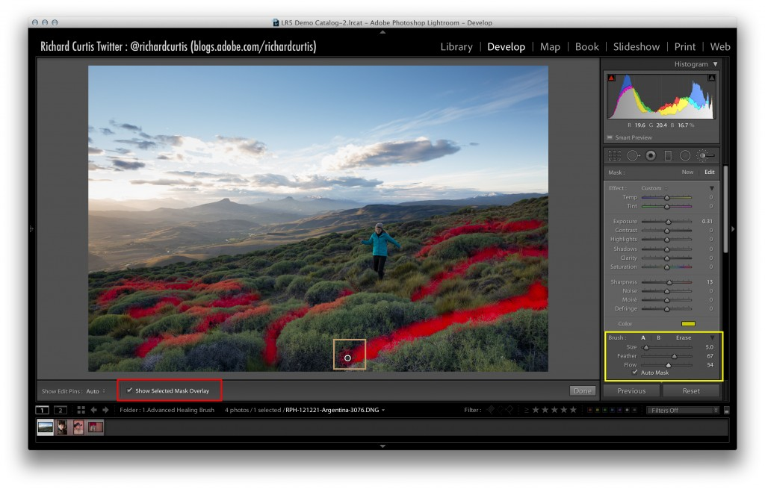
Scenario 2 – Change the colour of the persons jacket

This tutorial will use the adjustment brush to change the colour of the person’s jacket in the scene.
Operating the Adjustment brush tool
To work effectively on the picture with precision and focus on the jacket, Lightroom can be zoomed into the picture using the CMD (Mac)/ CTRL (PC) and the + key (to zoom out, use the CMD (Mac)/CTRL (PC) and – key).
To create a new mask, “New” is selected within the adjustment brush attribute panel, and pin is placed on the image (marked red), using a click with the mouse or pen. The flow of the mask is set to medium (marked yellow), which allows the adjustment(s) to be accurately controlled.
The jacket has a clearly defined hard edge against its background, this contrast can be used to focus the painting and make sure the mask is within the jacket only. Making sure that the “Auto Mask” feature on the adjustment brush properties is on (marked brown below), will tell Lightroom to evaluate the contrast at the edges, and will try not to paint the mask outside of the jacket. If the brush does happen to paint the mask out of this area, pressing the “ALT” key will turn the adjustment brush into a removal brush and will paint away the mask when applied (a – sign is displayed in the brush when this is enabled).
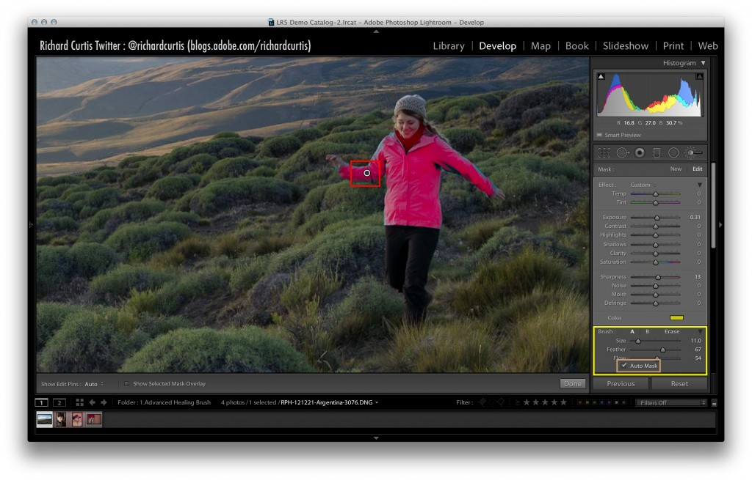

Adjustments to the jacket only can then be made, using the attributes in the adjustment brush panel. In the accompanying video, the jacket is turned a different colour by using the colour selector (at the bottom of the attributes panel). Combination of other adjustments is also allowed, which can be used to create your vision).
Scenario 3 – Change the brightness of the white area in a person’s eye.
This tutorial we’ll focus on how to brighten the whites of the eyes. This is a useful technique to draw the viewer’s attention into the photograph.
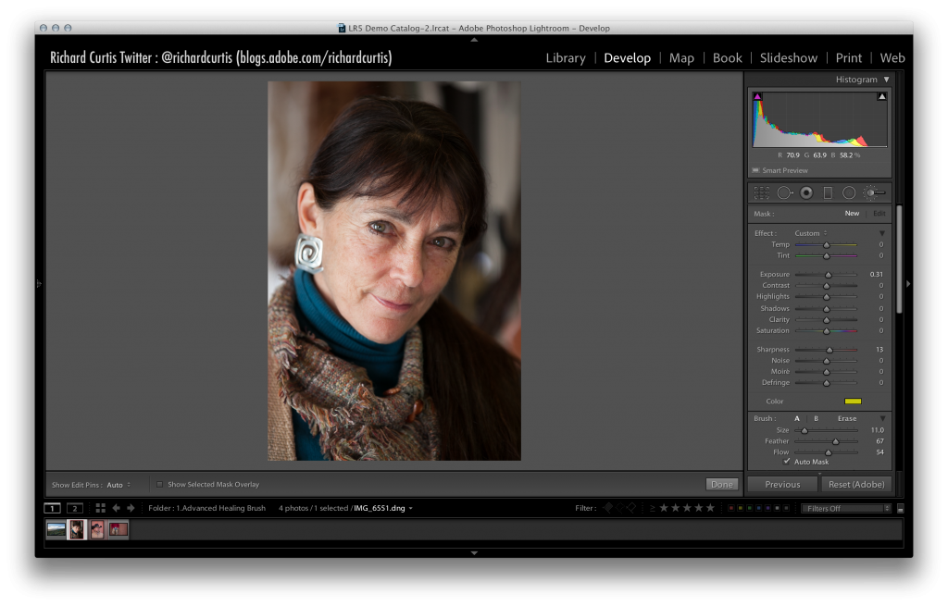

Operating the Adjustment brush tool
As in the previous tutorial the best practice for accurate and delicate work, is to zoom into the picture using CMD (Mac) / CTRL (Pc) and the + key (CMD (Mac) / CTRL (Pc) and the – key is used to zoom out).
Once the image is of a comfortable size (in the image below, both eyes are visible, as well as areas around the. This can be used to get feedback of the effect quickly). The operation to increase the brightness of the white part of the eye is the same as changing the colour of the jacket above. A new mask pin is placed on or near the eye (marked red below), and the “Show Selected Mask Overlay” is turned on (marked yellow). Within the brush attributes panel (marked red), the “Auto Mask” is turned on (to select only the white part of the eye). These options enable an accurate mask to be painted, and to control the adjustment strength of the effects.
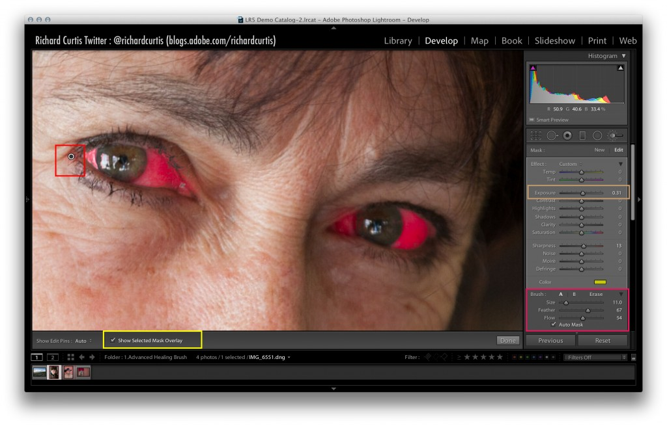
When the masks have been created, the ‘O’ key is pressed to turn of the “Show Selected Mask Overlay”, and then the exposure value is increased (moved to the right) to brighten the masked areas.
When applying any adjustments, it’s worthwhile previewing in the zoomed in mode, as well as zoomed out mode to see the effect that has been applied and to make sure that the creative vision is achieved, if not, the adjustments may need to be modified until the creative vision is reached.
Notice the whites of the lady’s eyes have been increased to add more visual attention for the viewer (marked red below).

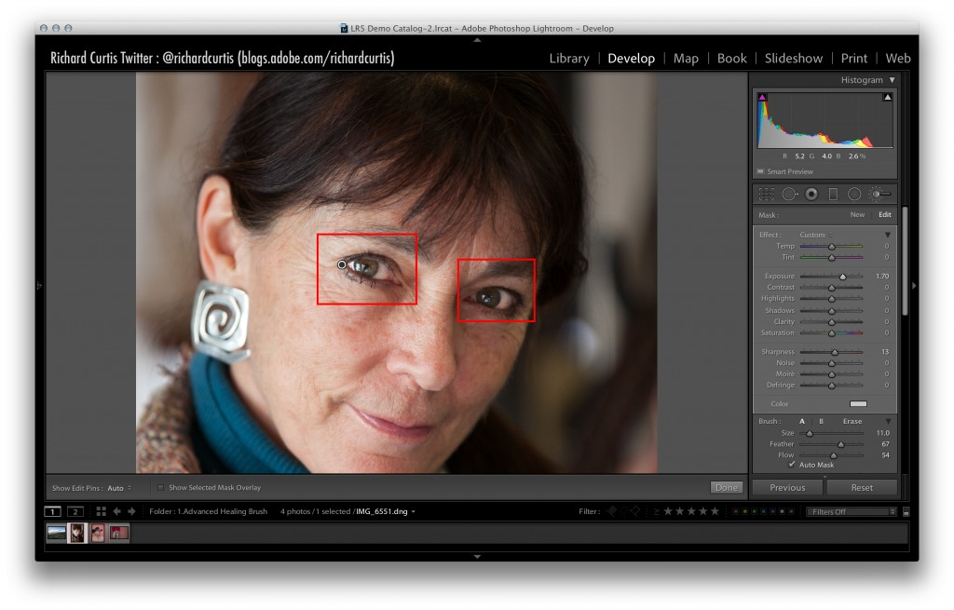

Crop Tool
The next example is to apply a crop to the scene. The crop tool is a great way to adjust the composition of the picture and change the story that is being told.
When cropping pictures you have a couple of options to consider. One of these options is the aspect ratio. The aspect ratio refers to the width and height of the image. As a starting point, this is determined by the camera, but of course can be changed using the crop tool.
The classic 35mm photography term is an aspect ratio and actually refers to an image being a ratio of 3 to 2. i.e. if the long side of a picture is 300pixels, then the short edge will be 200 pixels. There are other ratios that are used in photography; some examples of these are 5×7, 4×4 or10x8. The crop tool can be configured to keep to an aspect, and can be overlaid onto the picture from the menu tool bar, Tools / Crop Guide Overlay / Aspect Ratios.
When the crop tool is selected (marked yellow below), the bounding box will appear around the image (marked red). The crop tool can be modified by grabbing the corners or the middle of each edge of the crop box, then moving the crop bounding box. You may notice that sometimes when the crop bounding box is reduced in size, it will keep locked to a specific aspect ratio. This is due to the lock icon (marked brown) being set to ‘locked’. The lock can be released at any time and will disable the aspect ratio lock, the crop bounding box will then be allow to move freely.
You can also modify the locked aspect ratio by editing the ‘Aspect’ within the attributes panel (marked brown below). When this is modified, the physical size/shape of the crop bounding box will be changed, and allow re-positioning of the image.
A custom crop can be manually created, by selecting the two rulers next to the aspect ratios (marked brown below), and drawing over the picture with the mouse or pen.
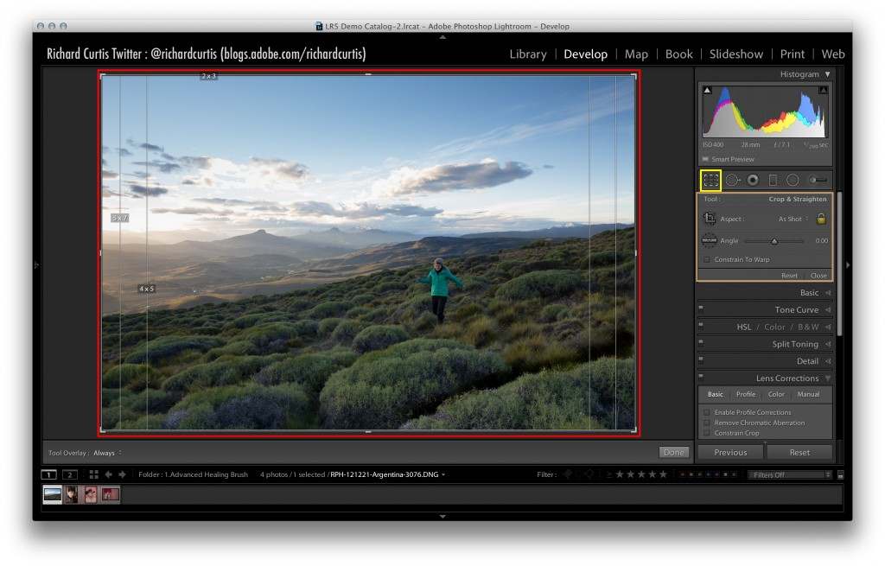

The ruler tool (marked red below) allows the image to be straightened, if required. To operate this tool, select the ruler and draw a straight-line on the image. In this example it will be drawn across the natural horizon. Once the ruler has been applied, the image will rotate and be straightened. The new picture after the rotation is show in yellow below.
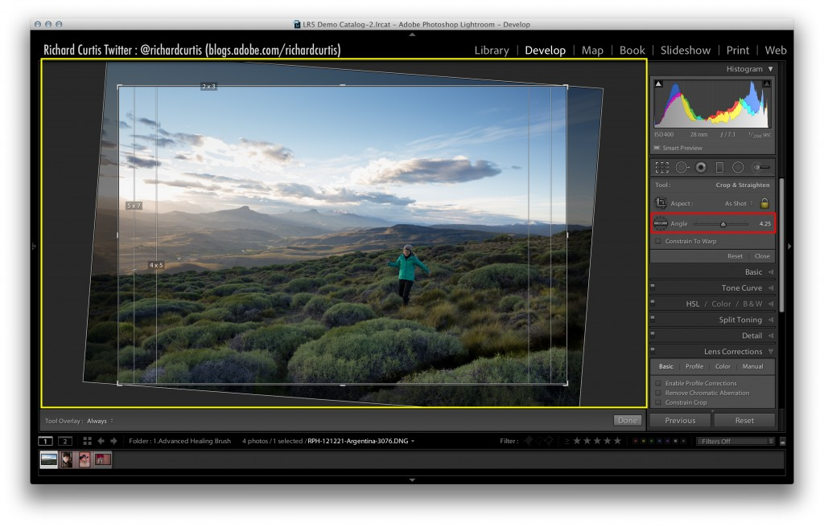

Radial Filter
The Radial filter can be used to apply an ellipse shape mask anywhere in the picture. One example of this is to focus the viewers attention on a certain part of the scene or keep the viewer in the picture and not drift out.
One traditional dark room techniques was to add darkness or burn the edges of an image (derived from the center of the photograph). This effect would be used to keep the viewer in the picture for a longer time. The “post crop vignette” (available under the effects panel) in Lightroom is used to create this effect.
The “post crop vignette” is very useful. However, sometimes an option to draw the same effect anywhere in the picture can be useful. In this example it will be used to focus the attention on the person running thought the scene.
The Radial filter is available with the other tools (marked yellow) and has the same adjustments (marked orange). When this filter is added to the picture, the pin for the shape will be displayed.
The default shape of radial filter is an ellipse, but, can be changed by dragging the shape handles (left or right hand side, top/bottom). These handles are marked red on the shape below. The tool also has blending properties (marked brown), so it can be faded into the picture and will be more difficult to see on the final image.
You can see in the picture following, the exposure has been applied to outside of the Radial filter, as well as a slight yellow tone.
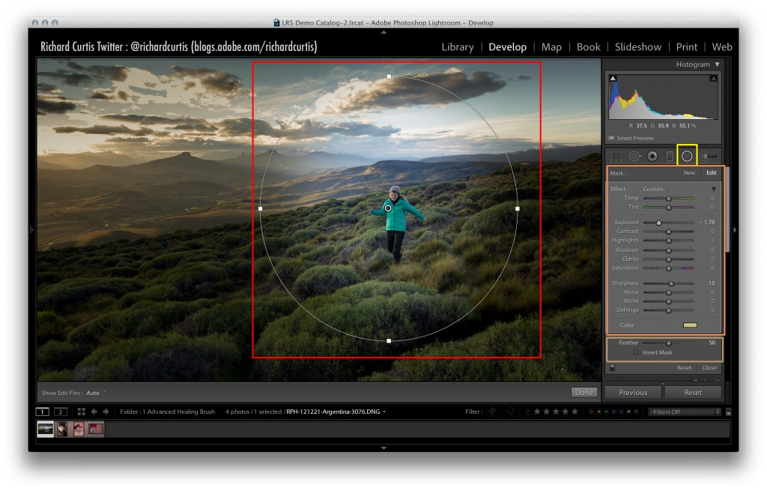
I hope that has given you a good overview of the local adjustment tools inside Lightroom, and we look forward to seeing what images you create using this very powerful RAW image editor.

N.B. The only tool that was not covered here was the Red Eye reduction tool. To use this tool, click the red-eye reduction (third from the left in the brushes and tools bar under the histogram) and find an area of the scene that needs to fixed (i.e. a human eye and not an animal), and click it. Lightroom will fix the red-eye and remove it from the picture.

